The Dining Philosophers Problem and Deadlock Prevention

Lane Dorscher
CS300-T301 Programming Languages (2261-1)
Bellevue University
10/05/2025
Ahmad Mostafa

Introduction
The dining philosophers problem, developed by Edsger Dijkstra, illustrates synchronization and resource-sharing challenges in concurrent systems. In the scenario, five philosophers alternate between thinking and eating. Each requires two forks to eat, but only five forks exist, one between every pair. This models processes that need multiple shared resources simultaneously, exposing potential issues of deadlock and starvation when access is not coordinated properly.

Deadlock and Starvation
A deadlock occurs when each philosopher picks up one fork and waits indefinitely for the second, resulting in a cycle where no one can proceed. This mirrors computer systems where processes hold one resource while waiting for another that will never be released. Starvation, on the other hand, happens when one philosopher is repeatedly unable to access the forks because others continually take priority. Even in deadlock-free systems, starvation can occur if the scheduling mechanism is unfair or lacks rotation in access.

Why Five Philosophers?
The problem traditionally uses five philosophers because it demonstrates a balanced circular dependency that exposes the potential for deadlock. Fewer participants, such as three or four, often avoid the issue due to reduced contention and asymmetry. Using five allows the example to model more realistic concurrency problems found in operating systems and distributed computing environments, where multiple processes compete for limited resources (Silberschatz, Galvin, & Gagne, 2022).

Deadlock-Free Solution
A straightforward method to prevent deadlock is to make philosophers alternate how they pick up forks. If everyone follows the same pattern, circular waiting can occur. The following Python-style pseudocode shows a deadlock-free approach:
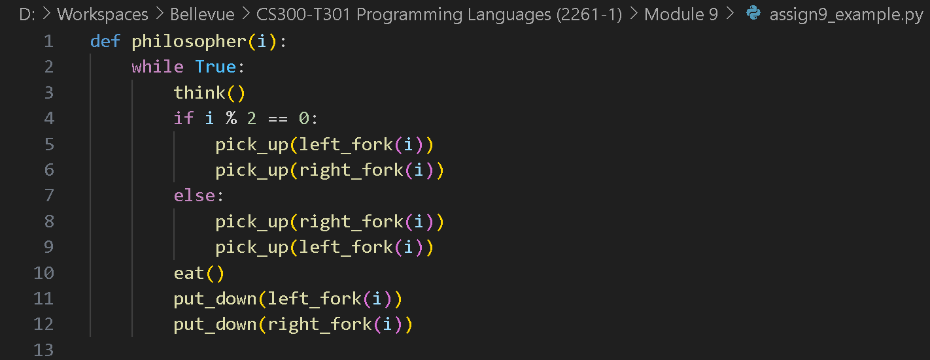
[Figure 1: Pseudo code written in Python.]

This method prevents circular waiting by alternating fork acquisition order, ensuring no two neighboring philosophers wait on each other indefinitely.

Conclusion
Although this solution eliminates deadlock, it does not fully guarantee freedom from starvation. A philosopher could still be delayed if resource access scheduling favors others repeatedly. To prevent starvation, fairness can be introduced through a queue or semaphore that ensures all philosophers eventually gain access in turn.

References
Silberschatz, A., Galvin, P. B., & Gagne, G. (2022). Operating system concepts (10th ed.). Wiley.

